Superstar Bulletin Paragraph Options
-------SCHOOL/CITY SPECIFIC--------
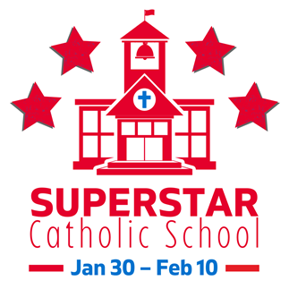
SUPERSTAR CONTEST : Who’s ready for Catholic Schools Week? We are! Vote for your favorite Catholic School(s), [Enter local School(s) name(s) here], in Spirit Catholic Radio’s Superstar Contest! For 11 years, Spirit Catholic Radio has been shining a spotlight on Catholic high schools and elementary schools in their listening area with the Superstar Contest. Let’s get our community talking about the importance of Catholic education by encouraging others in our community to vote! Superstar voting competition begins January 30 and lasts through February 10th. Visit https://spiritcatholicradio.com/ to vote!

-------GENERIC--------
SUPERSTAR CONTEST : Who’s ready for Catholic Schools Week? We are! For 11 years, Spirit Catholic Radio has been shining a spotlight on Catholic high schools and elementary schools in our listening area with our Superstar Contest. Vote for your favorite, or local, Catholic Schools! Get your communities talking about the importance of Catholic education by encouraging others in your community to vote! The Superstar Contest encourages them to see what a catholic education has to offer. Our voting competition begins January 30 and lasts through February 10th. On February 13, we will announce our 10 winners of the Superstar Catholic Schools Contest for 2023. Visit https://spiritcatholicradio.com/ to vote!

