Superstar Bulletin Paragraph Options
-------SCHOOL/CITY SPECIFIC--------

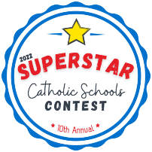SUPERSTAR CONTEST : Who’s ready for Catholic Schools Week? We are! Vote for your favorite Catholic School(s), [Enter local School(s) name(s) here], in Spirit Catholic Radio’s Superstar Contest! For 10 years, Spirit Catholic Radio has been shining a spotlight on Catholic high schools and elementary schools in their listening area with the Superstar Contest. Let’s get our community talking about the importance of Catholic education by encouraging others in our community to vote! Superstar voting competition begins January 31 and lasts through February 11th. Visit https://spiritcatholicradio.com/ to vote!

-------GENERIC--------

SUPERSTAR CONTEST : Who’s ready for Catholic Schools Week? We are! For 10 years, Spirit Catholic Radio has been shining a spotlight on Catholic high schools and elementary schools in our listening area with our Superstar Contest. Vote for your favorite, or local, Catholic Schools! Get your communities talking about the importance of Catholic education by encouraging others in your community to vote! The Superstar Contest encourages them to see what a catholic education has to offer. Our voting competition begins January 31 and lasts through February 11th. On February 14, we will announce our 10 winners of the Superstar Catholic Schools Contest for 2022. Visit https://spiritcatholicradio.com/ to vote!

