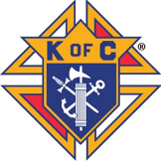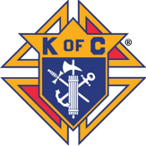

Fish Fry

All 7 Fridays during Lent

Dine In or Drive Thru

5 pm to 7:30 pm

*Dinners include Baked Potato or French Fries;*

*Coleslaw or Cup of Soup, Bread and Butter*

Baked Salmon (Fresh Atlantic) $13.00

Jumbo Shrimp - Deep Fried (5 pieces) $12.00

Fried Fish Fillet $10.00

Fish Sandwich Dinner (includes fries & coleslaw) $8.00

A LA CARTE

Fish Sandwich (4 oz. fish Fillet) $6.00

Slice of Cheese Pizza $4.00

Fries $2.00

Coleslaw $2.00

Clam Chowder Soup (Bowl) $4.00

 Beer, Wine and Cocktails Available for Drive Thru

Reservations: 402-291-6887 or

Email: knightseventcenter@gmail.com

Reservations Suggested

Catholic Daughters will be selling desserts

Credit Cards Accepted

1020 Lincoln Road, Bellevue, NE 68005