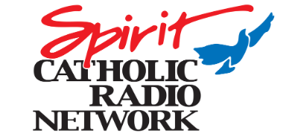
Position Title: Engineering Assistant
Reports to: Chief Engineer
Mission Statement
VSS Catholic Communications, Inc. is dedicated to answering the call of the late Holy Father, St. John Paul II, for a New Evangelization. Our charism in the mission of evangelization is to broadly employ broadcast media to transmit the Gospel of Jesus Christ with the fullness of the living Tradition as preserved, revered and proclaimed by the Catholic Church for 2000 years. Everyone involved recognizes this apostolate as an extraordinary gift, which we receive anew each day.
Responsibilities:
- Assist the Chief Engineer with operational issues maintaining technical standards.
- Support FCC compliance according to Code of Federal Regulations and the FCC compliance template.
- Assist in a preventative maintenance program to include scheduled inspection, cleaning, maintenance and monitoring of all equipment systems to insure optimum operation.
- Document equipment problems and any resolutions taken.
- Assist in any remote broadcast operations where technical intervention is needed, as well as operation of equipment, and communications with producer at the studio depending on event.
- Assisting with new projects, planning and building out.
- Assist in maintaining technical and EAS logs for all stations.
- Be able to handle issues when the Chief Engineer is absent.
- Assume on-call responsibilities as assigned.
- Perform other tasks as assigned.
- Continued education.
Experience and Skill Requirements:
- Strong faith life and respect for the Catholic teachings.
- Associates Degree in Radio/TV Broadcasting, or equivalent experience.
- 2+ years of broadcasting and/or technical radio experience.
- Exhibits attention to details.
- Be able to communicate professionally with other staff and people outside of the station.
- Some IT experience preferred.
- Ability to lift 50 pounds.
- Valid driver’s license required.
- Ability and willingness to travel, as directed.

