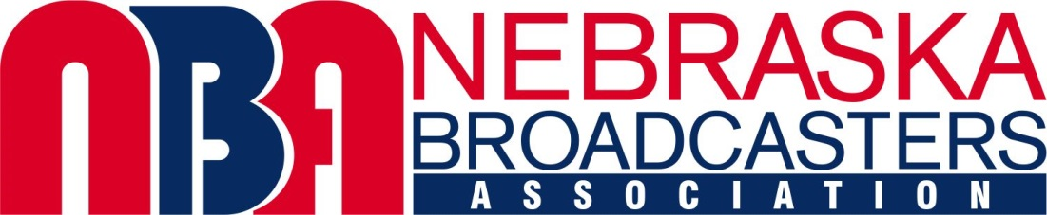

NBA FOUNDATION EEO SCHOLARSHIP PROGRAM

PROCEDURES
In 2022, the NBA Foundation is offering two, $2,000.00 scholarships to assist students enrolled in broadcasting-related educational programs at four-year public or private colleges and universities. Students who meet the following eligibility requirements are encouraged to apply. Completed applications and all required materials must be received at the NBA office no later than March 1, 2022.

ELIGIBILITY REQUIREMENTS
1) Applicant must be on track to complete 30 or more credits as of May 31, 2022; majoring in broadcasting, communications or a broadcasting-related field; at a four-year public or private college or university.

2) Applicant must have a Nebraska connection; having either graduated from a Nebraska high school OR be attending a four-year Nebraska college or university.

3) Applicant must be planning to pursue a career in radio or television broadcasting.

APPLICATION REQUIREMENTS
1) Applicant must complete the attached NBA Foundation EEO Scholarship Application Form.

2) Applicant must submit the following materials:
- Completed, typewritten application form (handwritten forms not accepted)
- Copy of current, official transcript
- Two, one-page recommendation letters supporting the application
- An original essay written by the applicant, answering: “Given the impact of social media and its relatively low production costs, how would you redesign the broadcast radio and/or TV industry to remain both relevant to the audience and economically viable?”
- Essay must be typewritten, double-spaced, and not exceed three pages in length

3) All applications and required materials must be received by March 1, 2022, at:
NBA Foundation
Attention: Jim Timm
11414 W. Center Rd., Suite 342
Omaha, NE 68144

NBA FOUNDATION EEO SCHOLARSHIP APPLICATION FORM: PAGE 1

IMPORTANT: Form may be computer-generated and photocopied. All information must be typewritten. Application form can also be submitted online: https://ne-ba.org/uncategorized/spring-nba-foundation-college-scholarships/

NAME:

COLLEGE/UNIVERSITY ATTENDING:

MAJOR:

# OF CREDITS TO BE COMPLETED AS OF MAY 31, 2022:

ANTICIPATED GRADUATION DATE:

PERMANENT ADDRESS:

ADDRESS AT SCHOOL:

MOBILE PHONE:

HOME PHONE:

EMAIL ADDRESS:

COMMUNITY AND STATE OF BIRTH:

NAME AND LOCATION OF HIGH SCHOOL FROM WHICH YOU GRADUATED:

NBA FOUNDATION EEO SCHOLARSHIP APPLICATION FORM: PAGE 2

NAME:

CAREER GOAL:

BROADCASTING EXPERIENCE: (may include internships, work at student broadcast facilities, and part or full time work experience)

POST-HIGH SCHOOL EXTRACIRRICULAR ACTIVITIES:

AWARDS AND HONORS:

CURRENT CUMULATIVE GRADE POINT AVERAGE:

Applicants may be asked to participate in a personal or electronic interview. This form and all required materials as previously outlined are due at the NBA Foundation office no later than March 1, 2022.

